Dear Torsten,

Please download the German language FW for PFM906:

<https://www.dropbox.com/s/qwifp19n863kh5e/PFM906_New_Update.zip?dl=0>

Please follow the instruction below to upgrade the FW:

1. Prepare a micro SD card.
2. Create a folder in root directory and name it “update”

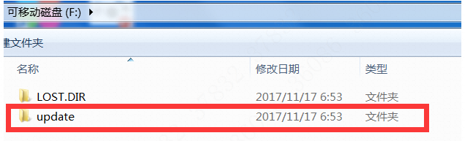

1. Open the **PFM906_New_Update.zip** FW package and extract it’s content to this folder.
2. Plug the micro SD card into PFM906.
3. Power it on, and find and tap “**Application update**” on the main menu(you may have to swap a few pages to find it).
4. Tap “**Local update**” then “**One button update**(the name of this button may be different in your version but the location is the same)”

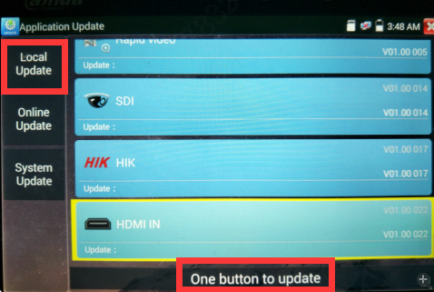

1. The device will update its applications, after the upgrade is complete, you can open “Settings” menu and find Deutsche language pack for you to choose.

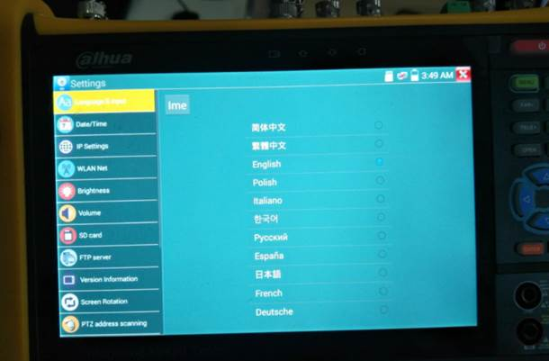

If you have any further question please feel free to contact us.